PROBLEM STATEMENT

KPI’s REQUIREMENT

We need to analyze key indicators for our sandwich sales data to data to gain insights into our business performance. Specifically, we want to calculate the following metrics

* Total revenue
* Average Order Value
* Total Sandwich Quantity Sold
* Total Orders
* Average Sandwich Per Order

CHART REQUIREMENT

1. Daily Trend for Total Orders:

Create a bar chart that displays the daily trend of total orders over a specific time period. The chart will help us identify any patterns or fluctuations in order volumes on a daily basis.

1. Hourly Trend for Total Orders:

Create a line chart that illustrates the hourly trend of total orders throughout the day. This chart will allow us to identify peak hours or periods of high order activity.

1. Percentage of Sales by Sandwich Category:

Create a pie chart that shows the distribution of sales across different sandwich categories. The chart will provide insights into the popularity of various pizza categories and their contribution to overall sales.

1. Percentage of Sales by Sandwich Size:

Generate a pie chart that represents the percentage of sales attributed to different Sandwich sizes. This chart will help us understand customer preferences for sandwich size and their impact on sales.

1. Total Sandwichs sold by the company:

Create a funnel chart that presents the total number of sandwich sold for each sandwich category. This chart will allow us to compare the sales performance of different pizza categories.

1. Top 5 Best Sellers by Total Sandwich Sold:

Create a bar chart highlighting the top 5 best selling sandwiches based on the total number of pizza sold. This chart will help us identify the most popular sandwich options.

1. Bottom 5 Worst Sellers by the Pizzas sold:

Create a bar chart showcasing the bottom 5 worst-selling sandwiches based on the total number of sandwiches sold. The chart will enable us to identify underperforming or less popular sandwich options.

Software Used

Microsoft Excel:

SQL Server Management Studio

**SANDWICH SALES SQL QUERIES**

1. What is the total revenue

SELECT

Round(SUM(total_price),2) As TotalRevenue

FROM

Sandwich_sales

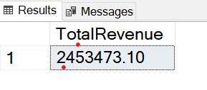

1. What is the average order value

SELECT

SUM(total_price)/COUNT(Distinct order_id) AS Avg_Order_Value

FROM

Sandwich_sales

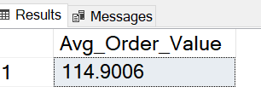

1. What is the total number of sandwiches sold

SELECT

SUM(quantity) AS Total_Sandwich_Sold

FROM

Sandwich_sales

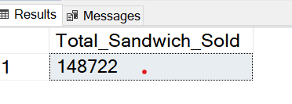

1. What is the total order placed

SELECT

COUNT(Distinct order_id) AS Total_Order

FROM

Sandwich_sales

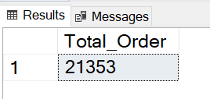

1. What is the average sandwich per order

SELECT

CAST((CAST(SUM(quantity) AS DECIMAL(10,2))/

CAST(COUNT(Distinct order_id) AS DECIMAL(10,2))) AS DECIMAL(10,2)) AS Average_Sandwich_Per_Order

FROM

Sandwich_sales

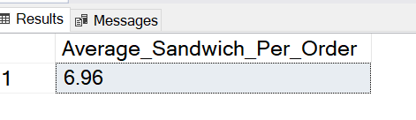

1. What is the daily trend for total orders

SELECT

DATENAME(DW,order_date) AS Order_Day,

COUNT(DISTINCT order_id) AS Total_Orders

FROM

Sandwich_sales

GROUP BY DATENAME(DW,order_date)

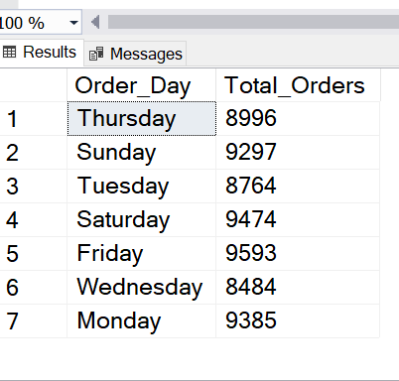

1. What is the hourly trend for total orders

SELECT

DATEPART(HOUR,order_time) AS Order_hours,

COUNT(DISTINCT order_id) AS Total_Orders

FROM

Sandwich_sales

GROUP BY DATEPART(HOUR,order_time)

ORDER BY DATEPART(HOUR,order_time)

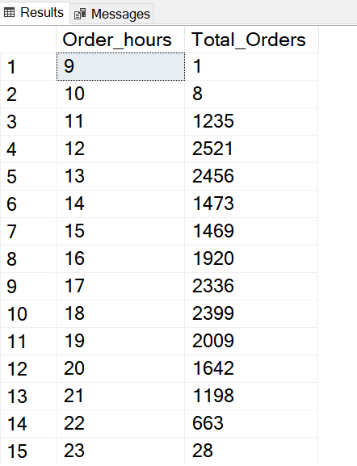

1. What is the total sales by Sandwich category

SELECT

Sandwich_category,

sum(total_price) AS total_sales

FROM

Sandwich_sales

GROUP BY Sandwich_category

ORDER BY Sandwich_category

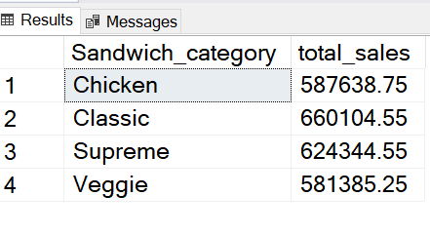

1. What is the percentage of sales by Sandwich category

SELECT

Sandwich_category,

sum(total_price) AS Total_Sales,

Round(sum(total_price)*100/(Select sum(total_price) from Sandwich_sales),2) AS Percentage_of_sales

FROM

Sandwich_sales

GROUP BY Sandwich_category

ORDER BY Sandwich_category

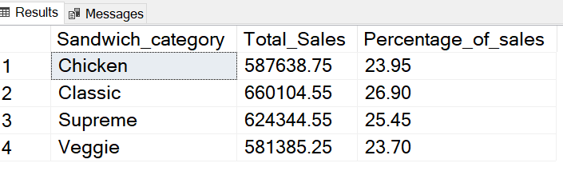

1. What is the percentage of sales by Sandwich category for the month of January

SELECT

Sandwich_category,

sum(total_price) AS Total_Sales,

Round(sum(total_price)*100/(Select sum(total_price) from Sandwich_sales WHERE MONTH(order_date)=1),2) AS Percentage_of_sales

FROM

Sandwich_sales

WHERE MONTH(order_date)=1

GROUP BY Sandwich_category

ORDER BY Sandwich_category

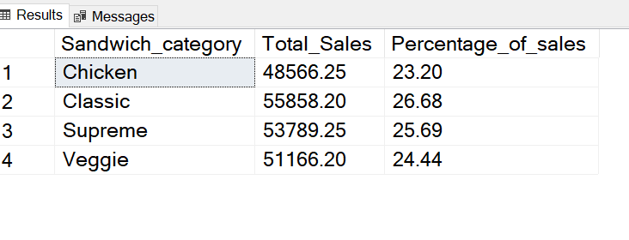

**Note: Month(order_date) = 1 indicates that the output is for the month of January.**

1. What is the percentage of sales by Sandwich size

SELECT

Sandwich_size,

sum(total_price) AS Total_Sales,

Round(sum(total_price)*100/(Select sum(total_price) from Sandwich_sales),2) AS Percentage_of_sales

FROM

Sandwich_sales

GROUP BY Sandwich_size

ORDER BY Sandwich_size DESC

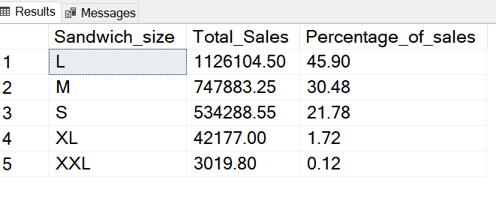

1. What is the percentage of sales by Sandwich size for 1st quarter

SELECT

Sandwich_size,

Sum(total_price) AS Total_Sales,

Round(sum(total_price)*100/(Select sum(total_price) from Sandwich_sales WHERE DATEPART(quarter,order_id)=1),2) AS Percentage_of_sales

FROM

Sandwich_sales

WHERE DATEPART(quarter,order_id)=1

GROUP BY Sandwich_size

ORDER BY Sandwich_size DESC

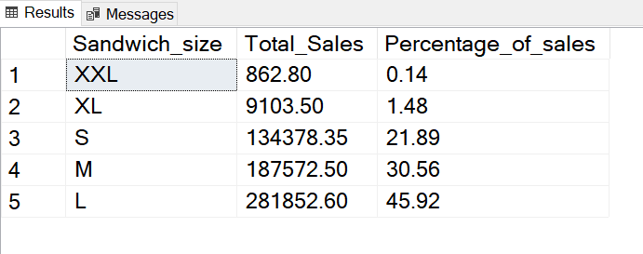

**Note: DATEPART(quarter,order_id) = 1 indicates that the output is for the 1st Quarter.**

1. What is the total sandwich order by sandwich category

SELECT

Sandwich_category,

sum(quantity) AS Total_Quantity,

Round(sum(quantity)*100/(Select sum(quantity) from Sandwich_sales),2) AS Percentage_of_Sandwich_Sold

FROM

Sandwich_sales

GROUP BY Sandwich_category

ORDER BY Sandwich_category DESC

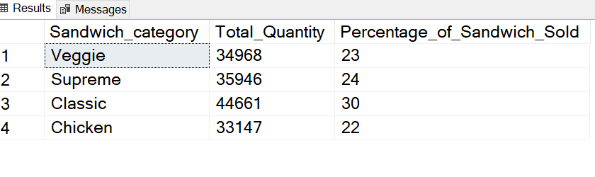

14. What is the top 5 best sellers by total pizza sold

SELECT TOP 5

Sandwich_name,

sum(quantity) AS Total_Sandwich_Sold

FROM

Sandwich_sales

GROUP BY Sandwich_name

ORDER BY sum(quantity) DESC

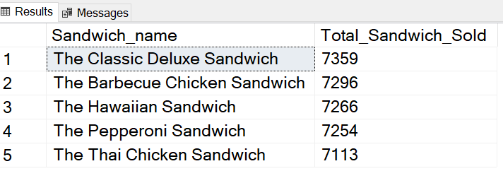

16. What is the bottom 5 best sellers by total pizza sold

SELECT TOP 5

Sandwich_name,

sum(quantity) AS Total_Sandwich_Sold

FROM

Sandwich_sales

GROUP BY Sandwich_name

ORDER BY sum(quantity)

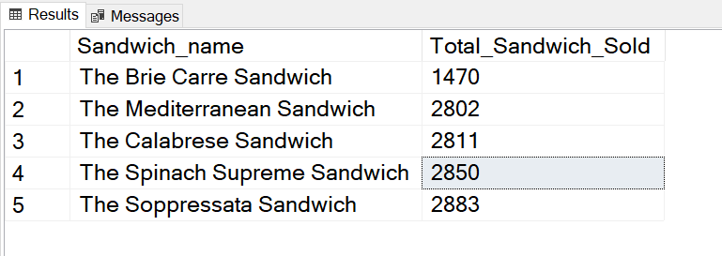

17 What is the percentage of sales by Sandwich size whose total sales is greater than 50000

SELECT

Sandwich_size,

sum(total_price) AS Total_Sales,

Round(sum(total_price)*100/(Select sum(total_price) from Sandwich_sales HAVING sum(total_price)>50000),2) AS Percentage_of_sales

FROM

Sandwich_sales

GROUP BY Sandwich_size

Having sum(total_price)>50000

ORDER BY Sandwich_size DESC

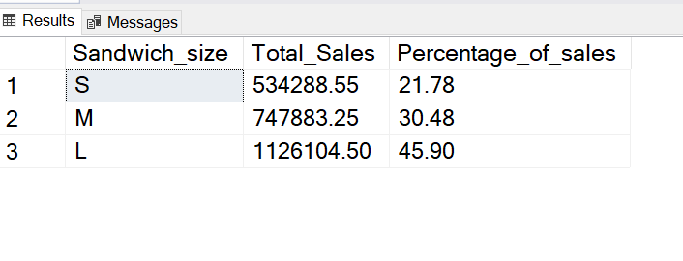

18. What is the top 10 of sandwich variety

SELECT TOP 10

Sandwich_ingredients,

COUNT(Sandwich_ingredients) AS No_of_Sandwich_Ingredients

FROM

Sandwich_sales

GROUP BY Sandwich_ingredients

ORDER BY COUNT(Sandwich_ingredients) DESC

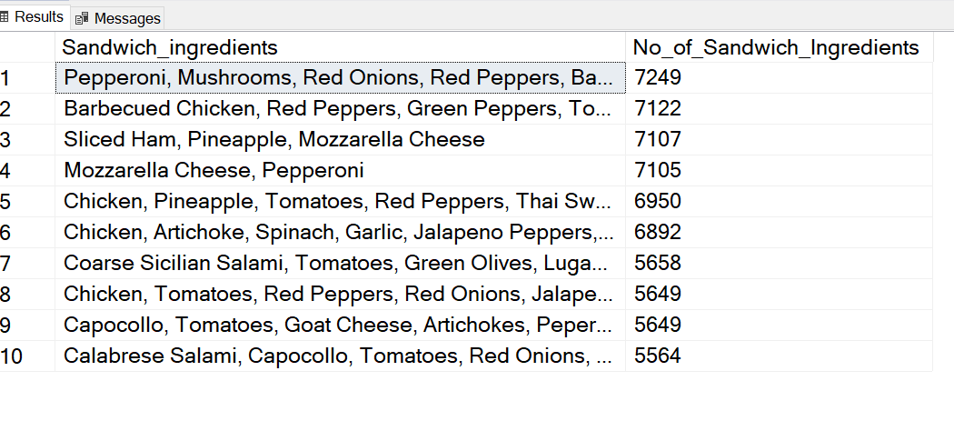19. Create sales_category based on the below criteria

Total price less than 50000-low sale, Total price between 50000 and 100000-Average sale, Others- High Sales

SELECT

Sandwich_name,

Sum(total_price) AS Total_Sales,

CASE

WHEN sum(total_price) <50000 then 'Low_Sales'

WHEN sum(total_price) BETWEEN 50000 AND 100000 then 'Average_Sales'

Else 'High_Sales'

END 'Sales_category'

FROM

Sandwich_sales

GROUP BY Sandwich_name

